Sprint 6

|  |  |  |
| --- | --- | --- |
| Cifrado | Decifrado | Hash |
| Z3VheWVyZA== | guayerd | Base64 |
| a788e21b2906dfdac17a8792dcd6fae2 | clase | md5 |
| dHV0b3I= | tutor | Base64 |
| 1055262e51509b80c6e91b9e4c3f143fee38e6dda4bef18f332128e58d5ac6c7 | educacion | sha256 |
| 6b05dc981252f903e435cb2e63180555bdca02b7 | palabras | sha1 |
| 6eca060e502486072928a51883981f6145c93143baab94c6a44d0141 | especialistas | sha224 |
| YXJnZW50aW5h | argentina | Base64 |

Alguna tomas o capturas de pantalla

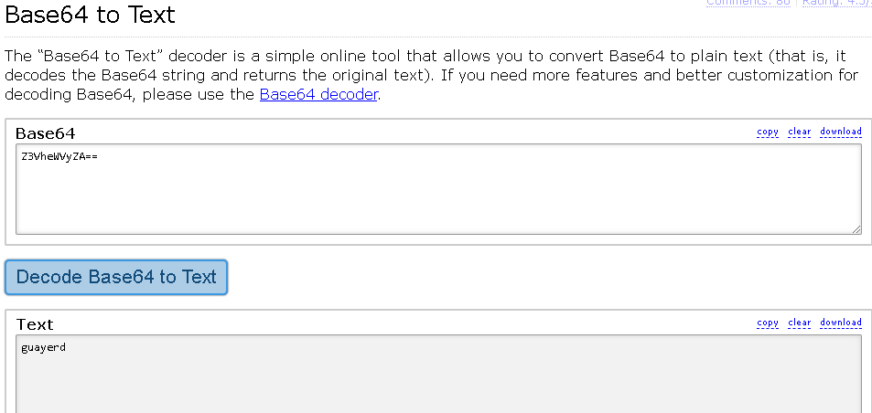

Herramenta: <https://base64.guru/converter/decode/text>

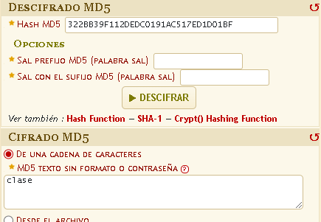

Fuente/Herramienta: <https://www.dcode.fr/funcion-hash-md5#f1>